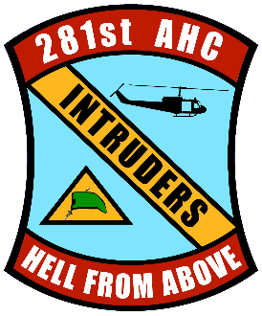

APPLICATION
281st ASSAULT HELICOPTER COMPANY ASSOCIATION
MEMORIAL SCHOLARSHIP
(Please type or complete this form using dark ink)

Name of Applicant: ____________________________________________________
Mailing Address: ______________________________________________________
_____________________________________________________________________
Telephone Number: ___________________ Birth Date: _____________________
What is your relationship to and the name of an individual who served in the 281st Assault Helicopter Company? ____________________________________________
Projected Date of High School Graduation:
Name and Address of High School:
______________________________________________________________________
Total College/University Semester Hours Earned:
College/University to be attended:
Potential/Declared Major/Minor:

Please attach a recent photo for potential media announcement purposes.

To help evaluate your qualifications, the Scholarship Board would like to get to know you as an individual; who are you, what you have accomplished in your life, and how you plan to use your education. Please add an additional page or pages to this application and provide, in essay form, the information requested in items 1, 2, and 3 below. You must provide this information for your application to be considered complete. Please be thorough in your responses.

1. Tell us about yourself: What do you like best in life? What is your community life like, and how do you contribute there? Do you have a part time job, or do volunteer work? If so, tell us about it.
2. Tell us about your schooling to date: What subjects do you like, and what are you better in? Do you participate in any extracurricular activities and/or sports? Tell us what you have done there. How about student government offices if any?
3. Tell us about your college plans: Why did you choose your college and field of study? How do you plan on using your college degree?

During the Vietnam War, the 281st lost ten men who were deemed missing in action (MIA) and are still unaccounted for. We honor them and work always to ensure they are not forgotten. Our Scholarship Awards are made in honor of those men. Should you receive scholarship support, it will be made in the name of one of our MIA. Your Award will always be named for that same man throughout your college career. You may find more information about our MIA/KIA at our website, 281st.com.

By my signature below, I certify that all the information on my application is factually correct. I also give the 281st Assault Helicopter Company Association permission to use my photo for media announcement purposes, and agree to hold the Association harmless for any issues that may arise involving same.

Signature: ____________________________________
Date: _________________

Form Revised: 2021/10/10

